# Infrastructure Description v1

Infrastructure Integration Roadmap Task

**Task Type(s)**: Coordination  
**Start by phase**: Integration  
**Complete by phase**: Ongoing  
**RP role(s)**: Resource integration coordinator(s), Documentation and knowledge base contact(s), System administrator(s)

## Summary

ACCESS resource providers, ACCESS projects, and other ACCESS affiliated online service providers (i.e. science gateways, etc.) enter basic information about their organization and then describe the infrastructure that they operate in the Cyberinfrastructure Description Repository (CiDeR). ACCESS infrastructure that is visible to researchers, resource providers, developers, other ACCESS awardees, or the broader community needs this description. Audience relevant filtered views of descriptions are displayed in different ACCESS websites.

### Effort

Initial setup:

* Organization PI, technical manager, or designee submits organization information and identifies their CiDeR administrator(s) (~1/2 hour)
* Organization CiDeR administrator authorizes other organization staff to enter and maintain infrastructure descriptions in CiDeR (~10 minutes)

Ongoing activities:

* Organization staff enter and maintain accurate infrastructure descriptions in CiDeR (~1 hour/year per resource)

## Prerequisite tasks

None

## Detailed Instructions

CiDeR is an evolutionary improvement of the XSEDE Resource Description Repository “RDR”. XSEDE hostnames and project references and the name RDR will be replaced by ACCESS and CiDeR during program year 1.

CiDeR is available at: <https://cider.access-ci.org/login>

### Initial CiDeR Setup

If your organization already has CiDeR/RDR access, skip to step C.

Submit a ticket with the Subject “New CiDeR Organization: at <https://support.access-ci.org/open-a-ticket>.

* Organization logo URL or attached file
* Organization public URL
* Organization PI/director name
* Organization PI/director email address
* External Data Posting
  + Organization ID Type either [GRID](https://www.grid.ac/) or [RINGGOLD](https://www.ringgold.com/ringgold-identifier/)
  + Organization ID
  + City, State, and Country
* The XSEDE/ACCESS usernames of individuals that will be CiDeR administrators for their organization. These individuals will be able to grant other individuals access to maintain infrastructure descriptions. A single individual can be the CiDeR administrator and the person entering and maintaining descriptions.

Submitted organization information will be entered by a CiDeR in a form as shown below and used to grant access to CiDeR administrators.

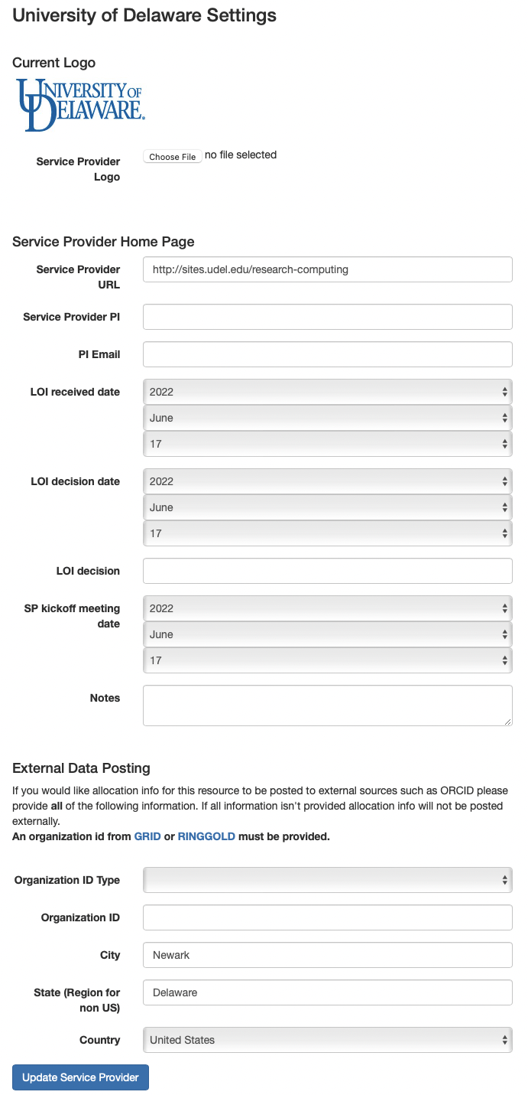

### Provide CiDeR access to other organization staff

The CiDeR administrator may grant other organization staff access to enter and maintain descriptions:

* Select “Service Providers” or “Organizations” along the top.
* Click on your “Organization” name.
* Click on “Administrators”.
* Add additional Organization Admins who may enter and update your organization resource information.

### Enter Resource Descriptions

Organization staff enter new infrastructure as detailed in the Quick Start Guide and User Guide:

<https://cider.access-ci.org/cider_manual_full.pdf>

Steps:

* Select “Resources” along the top.
* Click on your “Add a Resource” to add a new resource, or click on a resource name if your resource already exists.
* Enter as much information as possible in this first form
* Select a “Resource Type” at the bottom of the screen and “Create Resource”
* Enter as much information as possible in this second form

### Enter Resource Conversion Factors

If you resource is not ACCESS allocated, skip this section.

Page 16 of the CiDeR/RDR Manual has instructions for entering a “conversion factor”. This is the NU conversion factor of your resource, divided by 21.576. This will be used to compute your initial marketplace exchange rate. **For most compute resources, you should NOT change the conversion factor that you already have listed.**In a later stage of ACCESS, additional tools will be created to manage your variable marketplace exchange rate.

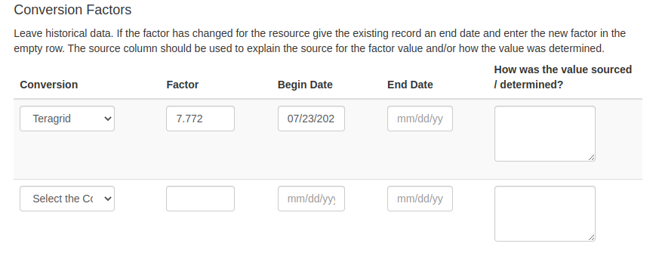

### Maintain infrastructure descriptions

Information in CiDeR should be kept up to date, and reviewed for accuracy at least once a year.

## Document Management

**Status**: Official

**Official date**: 03/15/2023

**Coordinators**: JP Navarro, ACCESS Operations; Nathan Tolbert, ACCESS Allocations

**Last revised date**: 03/07/2023

**Retired date**: